
PRESS RELEASE Ostrava, 5th May 2016

Nová Karolina Park office building has its own BookBooth

Nová Karolina Park in Ostrava opened a small public library in its atrium. Known as a BookBooth, it is converted from an old telephone booth. People can borrow or exchange books here free of charge or they can just read a bit while relaxing or waiting in one of the local cafes or restaurants. The gala opening of the BookBooth in the centre of Ostrava took place on May 4th, with the participation of football legends Antonín Panenka and Karol Dobiaš.

BookBooth is a non-profit project that originated in 2013 through the financial support of the Think Big programme, now known as O2 Smart Up. Since then the BookBooth team has already converted and put into operation more than 17 old telephone booths across the Czech Republic and inspired other enthusiasts to make dozens of public libraries that are revitalising public spaces.
“The Nová Karolina Park building is kind of a gateway leading to the historic centre of Ostrava, with thousands of people passing through here daily. Thus it is an ideal location for a BookBooth, which will be used not only by local residents and employees working in the building, but also by visitors to the city. I am glad that with this project we can support several good ideas. Not only the BookBooth project itself along with literature and reading, but also the non-profit organisation Anima Iuventutis, which we inform the public about through the BookBooths,” stated Kristýna Samková, Head of Marketing and PR of Marketing & PR from PASSERINVEST GROUP, with regard to the opening of the BookBooth in Nová Karolina Park.

“Thanks to the excellent cooperation with this partner our first BookBooth has also come to Ostrava. We hope that it will work just as well as in other cities where the BookBooth has appeared this year,” stated Pavel Železný, the co-author of the BookBooth project.

The Nová Karolina Park office building from PASSERINVEST GROUP is going up in a location that has genius loci and all the civic amenities as well as parking opportunities. Its attractiveness is even greater due to its position on Ostrava’s main street, 28. října Street, with a tram stop right by the building’s north reception, as well as an atrium that leads to the Forum Nová Karolina shopping centre. The building’s atrium is enlivened by works of art that were transformed from the gas emissions of the former mine workings. The more than 4000 people that pass through the atrium every day can use this space with fountains, benches and groups of diverse foliage, for relaxing during their lunch break, for meeting with friends over a coffee after a long day or for informal meetings with business partners outside of the office or just for sitting and reading on a bench.

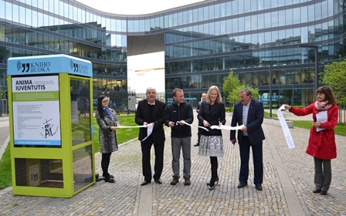
From the left Karol Dobiaš, Kamil Strak, non-profit organisation Anima Iuventutis, Kristýna Samková, Head of Marketing and PR of PASSERINVEST GROUP, and Antonín Panenka

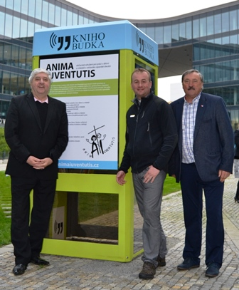

From the left Karol Dobiaš, Kamil Strak, non-profit organisation Anima Iuventutis, and Antonín Panenka

ABOUT THE BOOKBOOTH PROJECT
The non-profit BookBooth project originated in 2013 as a volunteer activity of Monika Serbusová and Pavel Železný. The goal is to create a free public library by converting old phone booths. At the current time it works on the principle of sponsorship/adoption, where the BookBooth team, after coming to an agreement with the sponsor, reconstructs an old booth in various styles and designs or remotely helps another team of volunteers with the modification and implementation. The logo and text of the BookBooth’s sponsor or adopter is always placed on one side of the booth and on the other side there is space for the free presentation of a local non-profit organisation.

ABOUT THE NOVÁ KAROLINA PARK PROJECT
The Nová Karolina Park office building is sensitively located in a newly-urbanised area of Ostrava near Masarykovo náměstí and it forms a “gateway” from the historic core of the city. The developer of the project is a joint venture between PASSERINVEST GROUP and GEMO OLOMOUC. The project’s architectural design comes from the drawing boards of Vít Máslo and David R. Chisholm of CMC architects. The entire project is spread out over 32 hectares of space on six storeys and it offers almost 24,600 m² of prime office space. This is supplemented on the ground floor with 3700 m² of space suitable for shops, services and restaurants. There are 279 underground parking spaces meant for the users of the building. Nová Karolina Park is certified as a green building according to BREEAM (BRE Environmental Assessment Method). The British BREEAM certificate is a prestigious methodology for the certification of green buildings in Europe.

PASSERINVEST GROUP, a. s., is a purely Czech development company, whose name is primarily connected with the construction of the multifunctional BB Centrum complex in Prague 4 – Michle. The company, founded in 1991 by Radim Passer, built a very good name on both a domestic and international level with this, the most successful and extensive Czech project of its kind. This is not only due to the quality of the implemented projects and the high level of provided services, but also to a sense of fair play, an accommodating relationship with the tenants/users of the buildings and the responsibility towards society and the environment. PASSERINVEST GROUP also has other interesting development projects in its portfolio.

For more information and photographs in print quality please contact:
Kristýna Samková, Head of Marketing and PR
PASSERINVEST GROUP, a.s.
Tel.: (+420) 221 582 111, fax: (+420) 222 515 521
Mobil: (+420) 602 186 708
E-mail: Kristyna.Samkova@Passerinvest.cz
www.passerinvest.cz, www.bbcentrum.cz

Marcela Štefcová
Crest Communications a.s.
Tel.: (+420) 222 927 125
Mobile: (+420) 731 613 669
E-mail: marcela.stefcova@crestcom.cz
www.crestcom.cz

